**Stack Swapping**

**Problem:** We have several distinct books stacked over each other. We need to place them  at a different location but we are looking to maintain the order of the stacked books. Books  are quite heavy and we can pick only one book at a time. Moreover, you can also get help  from your friend in doing this but the problem is that he can also hold only one book at a  time.

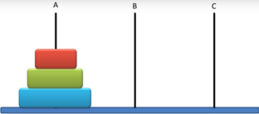

For example, in the above diagram we have 3 books stacker over each other at location A. We need  to stack them in the same order at location B. We can lift only 1 book that is at the top of the pile at  a time, we have also got a location C that can hold at most 1 book at a single time. Think of A & B as  stacks and C as a integer variable.

**Explanation:**

▪ You need to get input from user. List of id’s of books in the order in which they are stack on  each other. For example, 1 2 3 4 5 contains 5 distinct books having id’s from 1 to 5, 1 being  at the top of the pile and 5 being at the bottom of the pile.

▪ After taking the input from the user you have to implement a stack and populate it with data  taken from the user (1 at the top of stack and 5 at the bottom of the stack). This is going to  be your source stack.

▪ You need to make another stack that is going to be your destination stack. This will be  initially empty.

▪ You can only use two integer variables other than the two-stack implemented above. Hint: Variables can be used to temporarily store an element of stack.

▪ Your goal is to map source stack to the destination stack as shown in the diagram below.

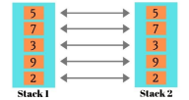

▪ **Output:** Print both the source stack and the destination stack.